dsfdsf
To Launch Secure Mode assessments following SSL certificates need to be imported in your browser.
Steps To Install Certificate:
Note: Please import all the certificates using the same procedure.
- Double click on the certificate. Click on “Install Certificates”.
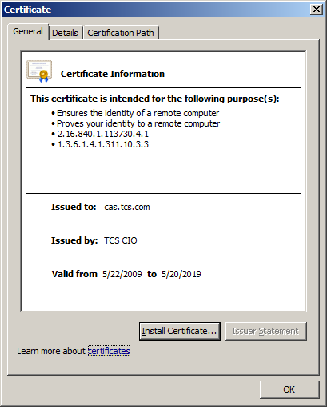
- In the Certificate Import Wizard, Click on “Next” button.
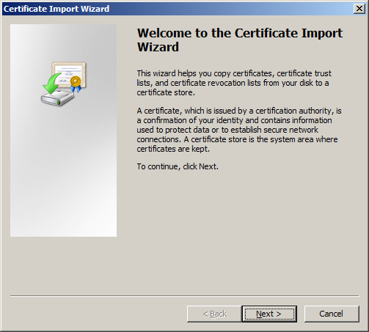
- Select the option “place all certificates in the following store” and Click on “Browse” button
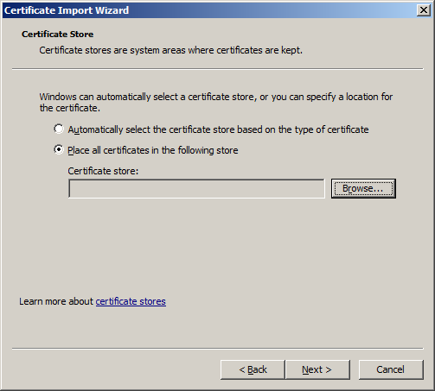

- Select the folder “Trusted root Certification Authorities” and Click on “OK”.
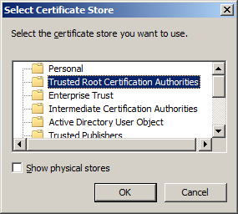
- Click on on “Finish” in the “Completing the Certificate import Wizard”.
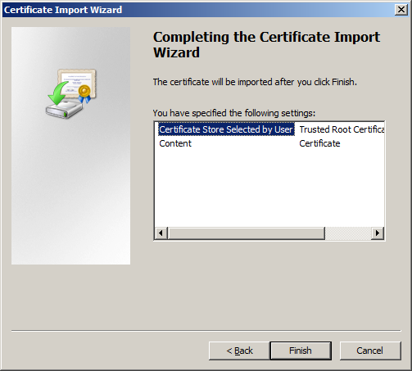

- Upon clicking “Finish”, if you get a “Security Warning” window, click on “Yes” to continue the installation of the Certificate
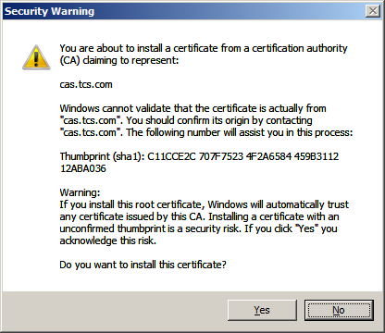
- An alert will pop-up saying “The import is successful”
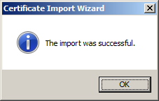

The certificate is imported properly now. Assessement can be launched from iCALMS.

